**GLEADELL MARKET REPORT**

**WHEAT AND OILSEED RAPE**

**Immediate – 3 February 2017**

**David Sheppard, Gleadell’s managing director, comments on the wheat market**

UK wheat prices have eased slightly over the past week with sterling continuing to be volatile.

Delivered premiums have also edged lower, as the two bioethanol plants appear to have bought significant volumes recently and have no immediate requirement for further cover in February and March.

Their absence from the market has a knock-on effect, not only in their natural supply area, but further south too.

Matif and Chicago futures markets have had a reasonably volatile week, due to a mix of fund short-covering, concerns over tensions between Russia and Ukraine, a number of international tenders and doubts about the availability of quality wheat in Europe.

There are no major weather scares at present, as adequate snow cover is present in vulnerable regions of the world.

Since 24 June, many traders have been talking about the currency inflation effect on today’s UK grain prices. The graph below shows a comparison between US wheat, US corn, French wheat, and UK wheat prices in US dollar terms since August 2014.

In dollar terms, UK prices have traded in a very narrow range since June 2016, whilst in sterling terms, they have appreciated by £30+.

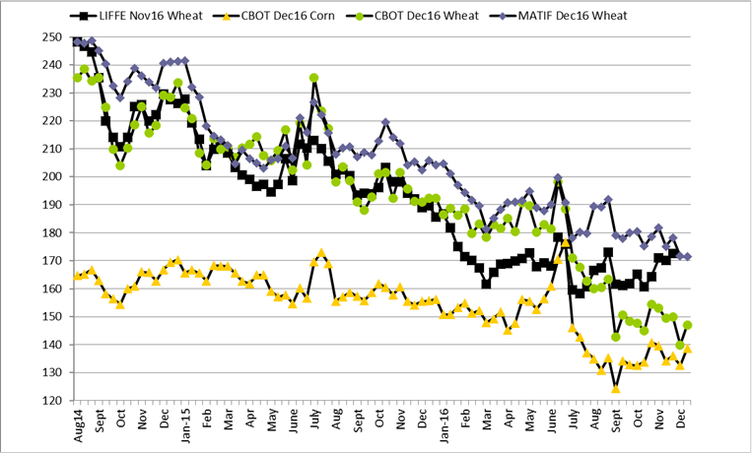

(COPY ENDS 192 WORDS)

**Jonathan Lane, Gleadell’s trading director, comments on the OSR market**

After achieving contract highs on the May17 MATIF contract last week, the now front-month contract took a breather with a €15 pullback. This was matched by a decline in sterling, initially protecting UK prices against most of the futures-led decline.

This week’s Commons vote to allow Theresa May to begin the Brexit process has had little effect on sterling, which has seen volatile conditions as the Bank of England inflation and growth forecasts are digested. This, combined with the decline in MATIF, means ex-farm OSR prices now stand £12/t lower than a week ago.

Weather worries in South America that supported soybean futures have now been partially discounted. The market reacting negatively, which was then mirrored in the MATIF contract. With Australian oilseed rape cargoes a week closer to European shores, and UK crushers not in the market due to poor crush margins, UK OSR prices may feel more pressure as trade shorts reduce bids against perceived crop tightness.

(COPY ENDS 159 WORDS)

**For market information contact** Jonathan Lane, trading director, on 01427 421221 or jonathan.lane@gleadell.co.uk

**Press queries or for further Gleadell contacts call** Robert Harris Communications on 07768 402850 or robert@roberthcomms.co.uk

**Notes to Editors**

Gleadell Agriculture Ltd is an independent major trader of grain, seed and fertiliser in the UK with offices in York, Hemswell (Lincolnshire), Swaffham (Norfolk), Stamford (Lincolnshire) and Warminster (Wiltshire). Gleadell is jointly owned by [ADM](http://www.adm.com/) and [InVivo](http://www.invivo-group.com/).

Any prices quoted in this release are indicative only at the time of going to press and subject to location and quality. Although Gleadell takes steps to ensure the validity of all information contained within this release, it makes no warranty as to the accuracy or completeness of such information. Gleadell will accept no liability or responsibility for the information, or any action or failure to act, based upon such information.